Title. Remarks for Authors

Firstname NAME (Organisation)*
Firstname NAME (Organisation)
Firstname NAME (Organisation)
Firstname NAME (Organisation)

Abstract: max. 500 characters

Key Words: max. 5 key words

Scope of Contributions
The program commitee of the Urban Operations Expert Talks 2022 welcomes any contribution to the challenges of urban operations to improve the interdisciplinary capabilities for mission accomplishment. The topic for the UOET 22 is “Introducing the Urban Operations Support Cell, a further development of the SubSurface Operations Cell (SSOC):
“Mission accomplishment within complex scenarios in subsurface service structures heavily depends upon the availability of specialised knowledge to assist the decision-making-process—provided by theSubSurface Operations Cell (SSOC). Without integration of this specific expertise, a subterranean operation is prone to end up in a severe mission creep causing avoidable damage and losses of personnel.” (Hofer 2020, p. 667)

Submission Procedure
After registration for the conference, paper submission is accessible and open until 26th June 2022, the result of the peer-review process should be available within several days.

Formatting: Headings (Garamond, 13pt, bold)
  - Sub-Headings (Garamond, 12pt, underline)

The paper must be written in English and not exceed 6 pages.
Headings: Garamond, 13pt, bold
Sub-Headings: Garamond, 12pt, underlined
Main body: Garamond, 11pt, single-line spacing, justify, add space after paragraph
Citations: Garamond, 11pt, italic, center
Using Citavi with the Word Add-in and citation style „Citavi Default Style“ will enable better collaboration by using the „Urban Operations Expert Talks“ Citavi Cloud for which we can activate you on request after registration. The publication bibliography will also be generated automatically then.

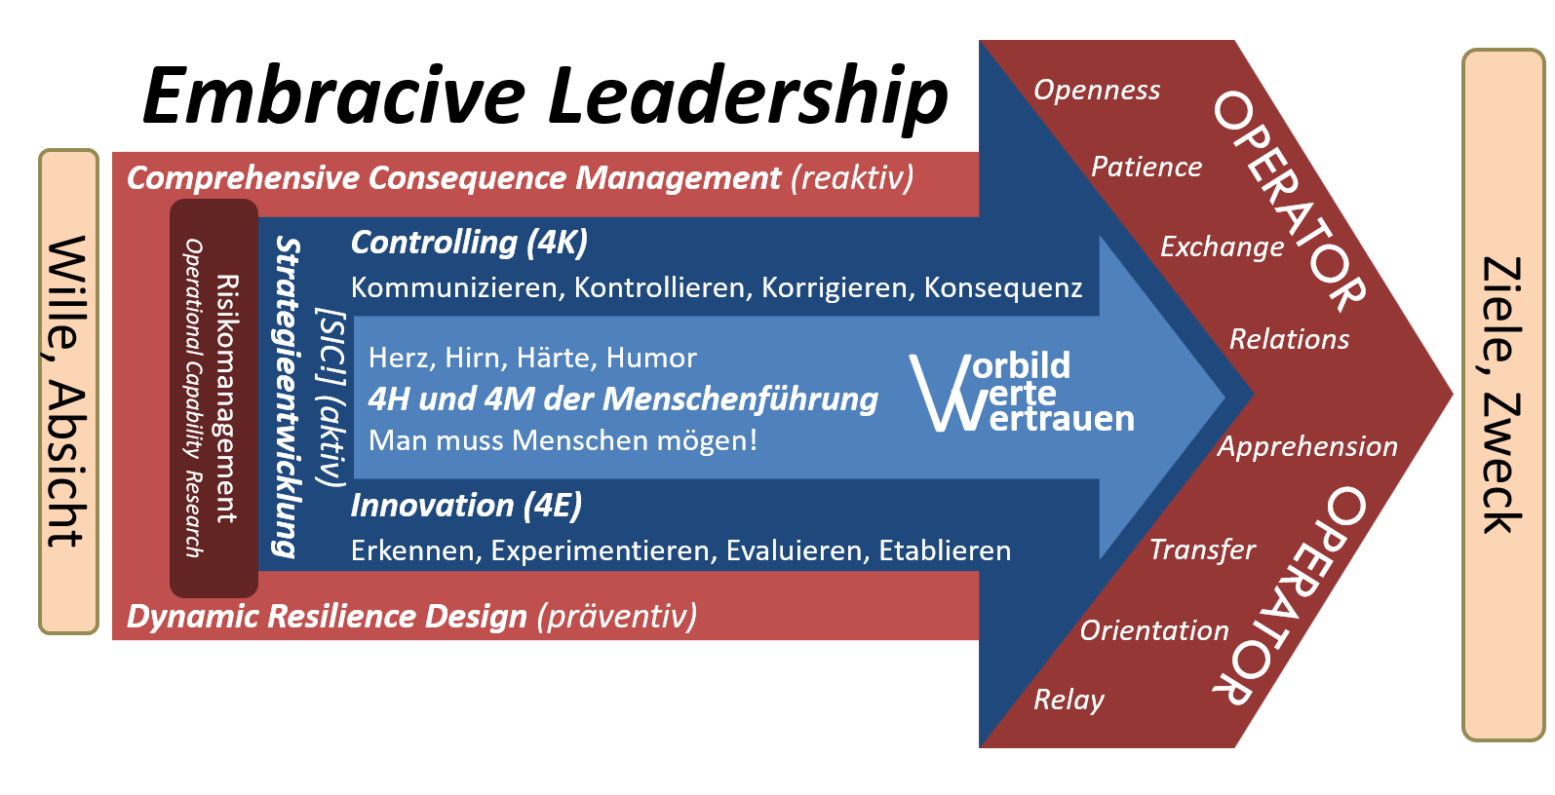
Figure 1: The Embracive Leadership Model has proven to be a useful tool for a wide range of applications. (Hofer 2018, p. 455)
Figures (Figure 1) and tables (Table 1) must be referenced in the text.
Table 1: Tables can also be used in the following format.
Content 1 | Content 2 | Content 3 | Content 4

Publication
Your paper will be subject to a double - blind peer review process. The publication will be published online on the conference homepage.

Contact
If you have any questions, please feel free to contact the editors at any time.
uoet@unileoben.ac.at

Publication bibliography
Hofer, Peter (2020): The SubSurface Operations Cell: High-value Asset for Decision-Making in Complex SubTerranean/SubSurface Operations. In Berg Huettenmaenn Monatsh 165. DOI: 10.1007/s00501-020-01060-4.

https://uoet.unileoben.ac.at [dd.mm.yyyy]
https://www.subsurface.at/uoet

